
D O K U Z E Y L Ü L U N I V E R S I T Y
FACULTY OF ENGINEERING

COMPUTER ENGINEERING DEPARTMENT

Project Final Report

Course : CME1101 - Project Based Learning -1
Project No : Date: 22/01/2013
Project Name : DNA Game

Prepared By : Berkay TÜRKGELDİ

No: 2011510105

1. Project Description

The aim of the project was to develop a tetris game. The game is played with one player and in the game, the player constructs DNA using tetris blocks and tries to gain the highest score.
We started to write algorithm of the game in 14 December and it taked four week for us. On the other hand, the game requires DNA knowledge a little bit but our project description includes everything about the project

2. Task Summary

2.1. Completed Tasks
Member | Task
Berkay TÜRKGELDİ | Control of the falling blocks, determining if the string is anagram, reverse, or one of RGC, creating bomb and control its possibilities

2.2. Uncompleted Tasks
Member | Task and Reason
Berkay TÜRKGELDİ | There is no uncompleted task in the project

2.3. Additional Improvements to the Project
Member | Additional Improvement
Berkay TÜRKGELDİ | We added level selection for user to improve the game. At the same time, we added an improvement that when user press the down arrow, the falling block falls immediately

3. Explanation of Algorithms

3.1. Screenshots

We used 12 functions to improve the algoritm’s functionality. We divided the problem into several tasks and we solved these tasks firstly. After that, we combined the functions in the main function.

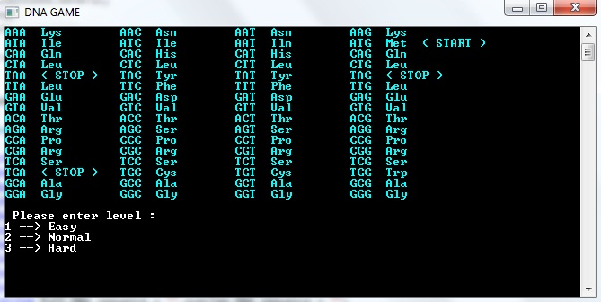

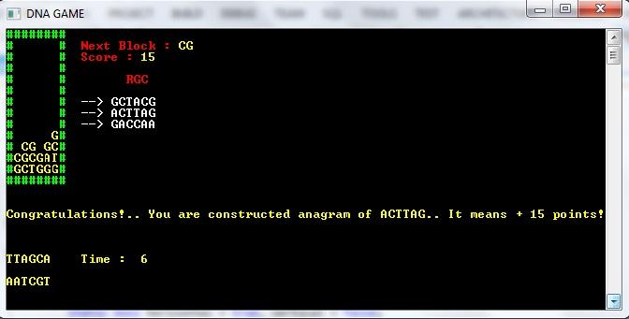

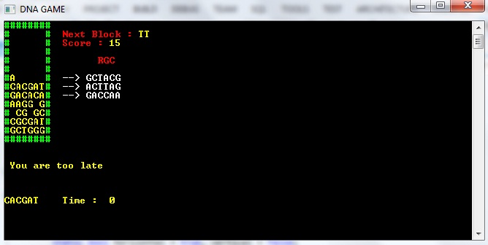

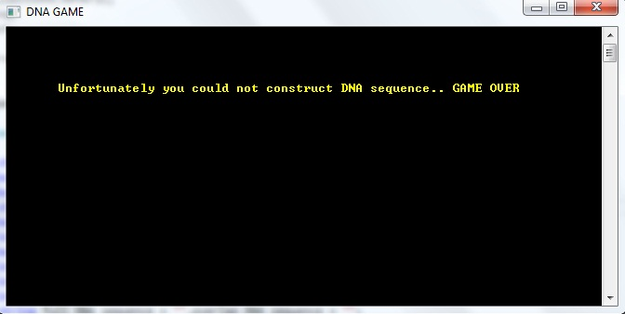

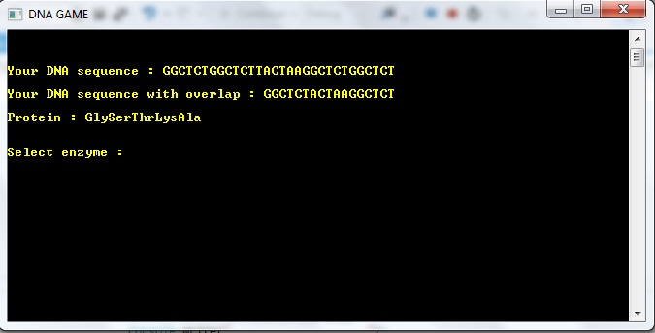

3.2. Functions

Functions; Parameters;

Create_block char[,] screen = new char[8, 14]
Fall bool stop_game = false
Pair bool start_falling = true, falling = true
Reverse bool horizontal = true, vertical = false
One_of_RGC string falling_block, next_block
Reverse_of_RGC bool left = false, right = false
Anagram_of_RGC int rotate_number = 0
Control bool bomb = false, bomb_begin = false
Destroy_and_slide int score = 0
Overlap int milisecond
Information string full_DNA_sequence = "",overlap_DNA_sequence = ""
Game_end string rgc_1,rgc_2,rgc_3

3.3. Algorithms

In the project, we thought that we must divide main problem in smaller problems and we used many functions for it
For instance, there is falling function

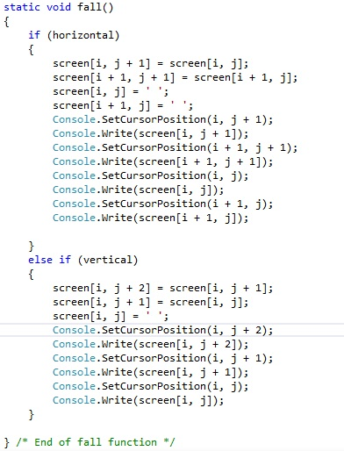

Member | Algorithm/Solution strategy
Berkay Türkgeldi | We call the fall function every constant time which can change with respect to level. The function arranges the array when block falls and at the same time, it changes the screenshot for us. It has a particular task.

4. Problems Encountered
Member | Problems and Solutions
Berkay Türkgeldi | → When a block is falling, sometimes the block stopped immediately  We solve the problem with using (>=) comparison instead of (==) while we compare difference and milisecond  → While entering twisted pair,game stops for 10 seconds. When we count down the time, in the screen,the time variable display blinked constantly  We added an if condition into while loop and if condition is processed every one second

5. Conclusions
Tecnically, we have learned how to use string operations in our projects. At the same time, we improved our two dimentional array knowledge and we started to implement it easily. Also, we have learned how to create functions and separate the main problem into smaller part.
Socially, the project improved our team work as well

6. References
ocw.mit.edu/courses/electrical-engineering-and-computer-science

7. Appendices
7.1. Poster/Web page of the Project

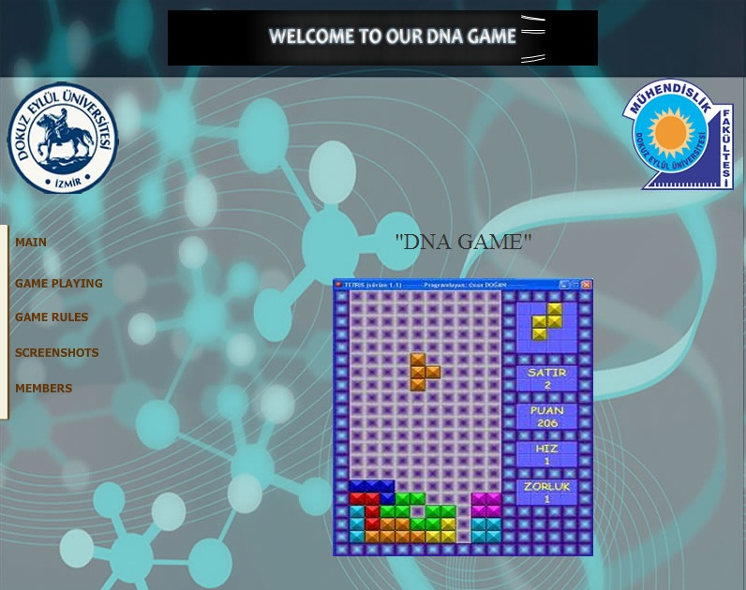
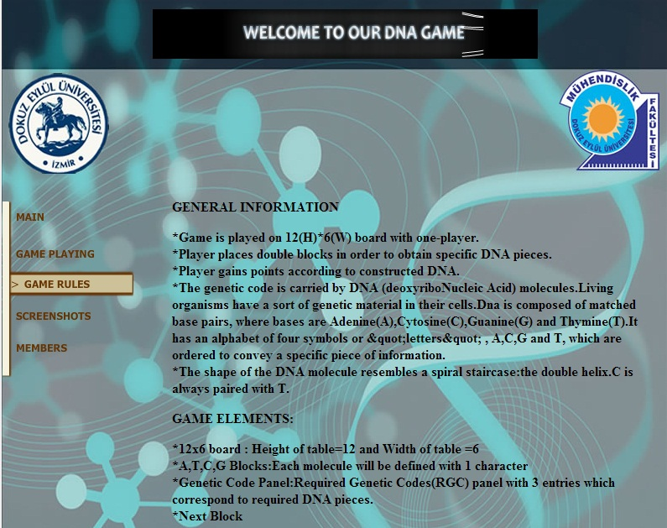

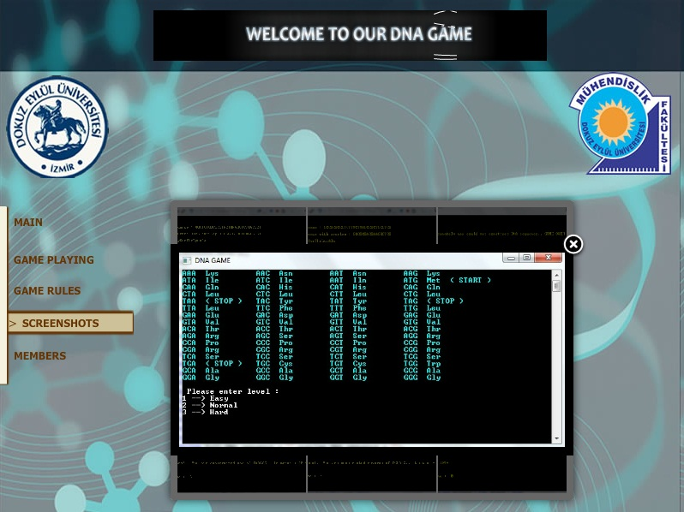

7.2. Code of the Project
Here are some functions codes of the project




